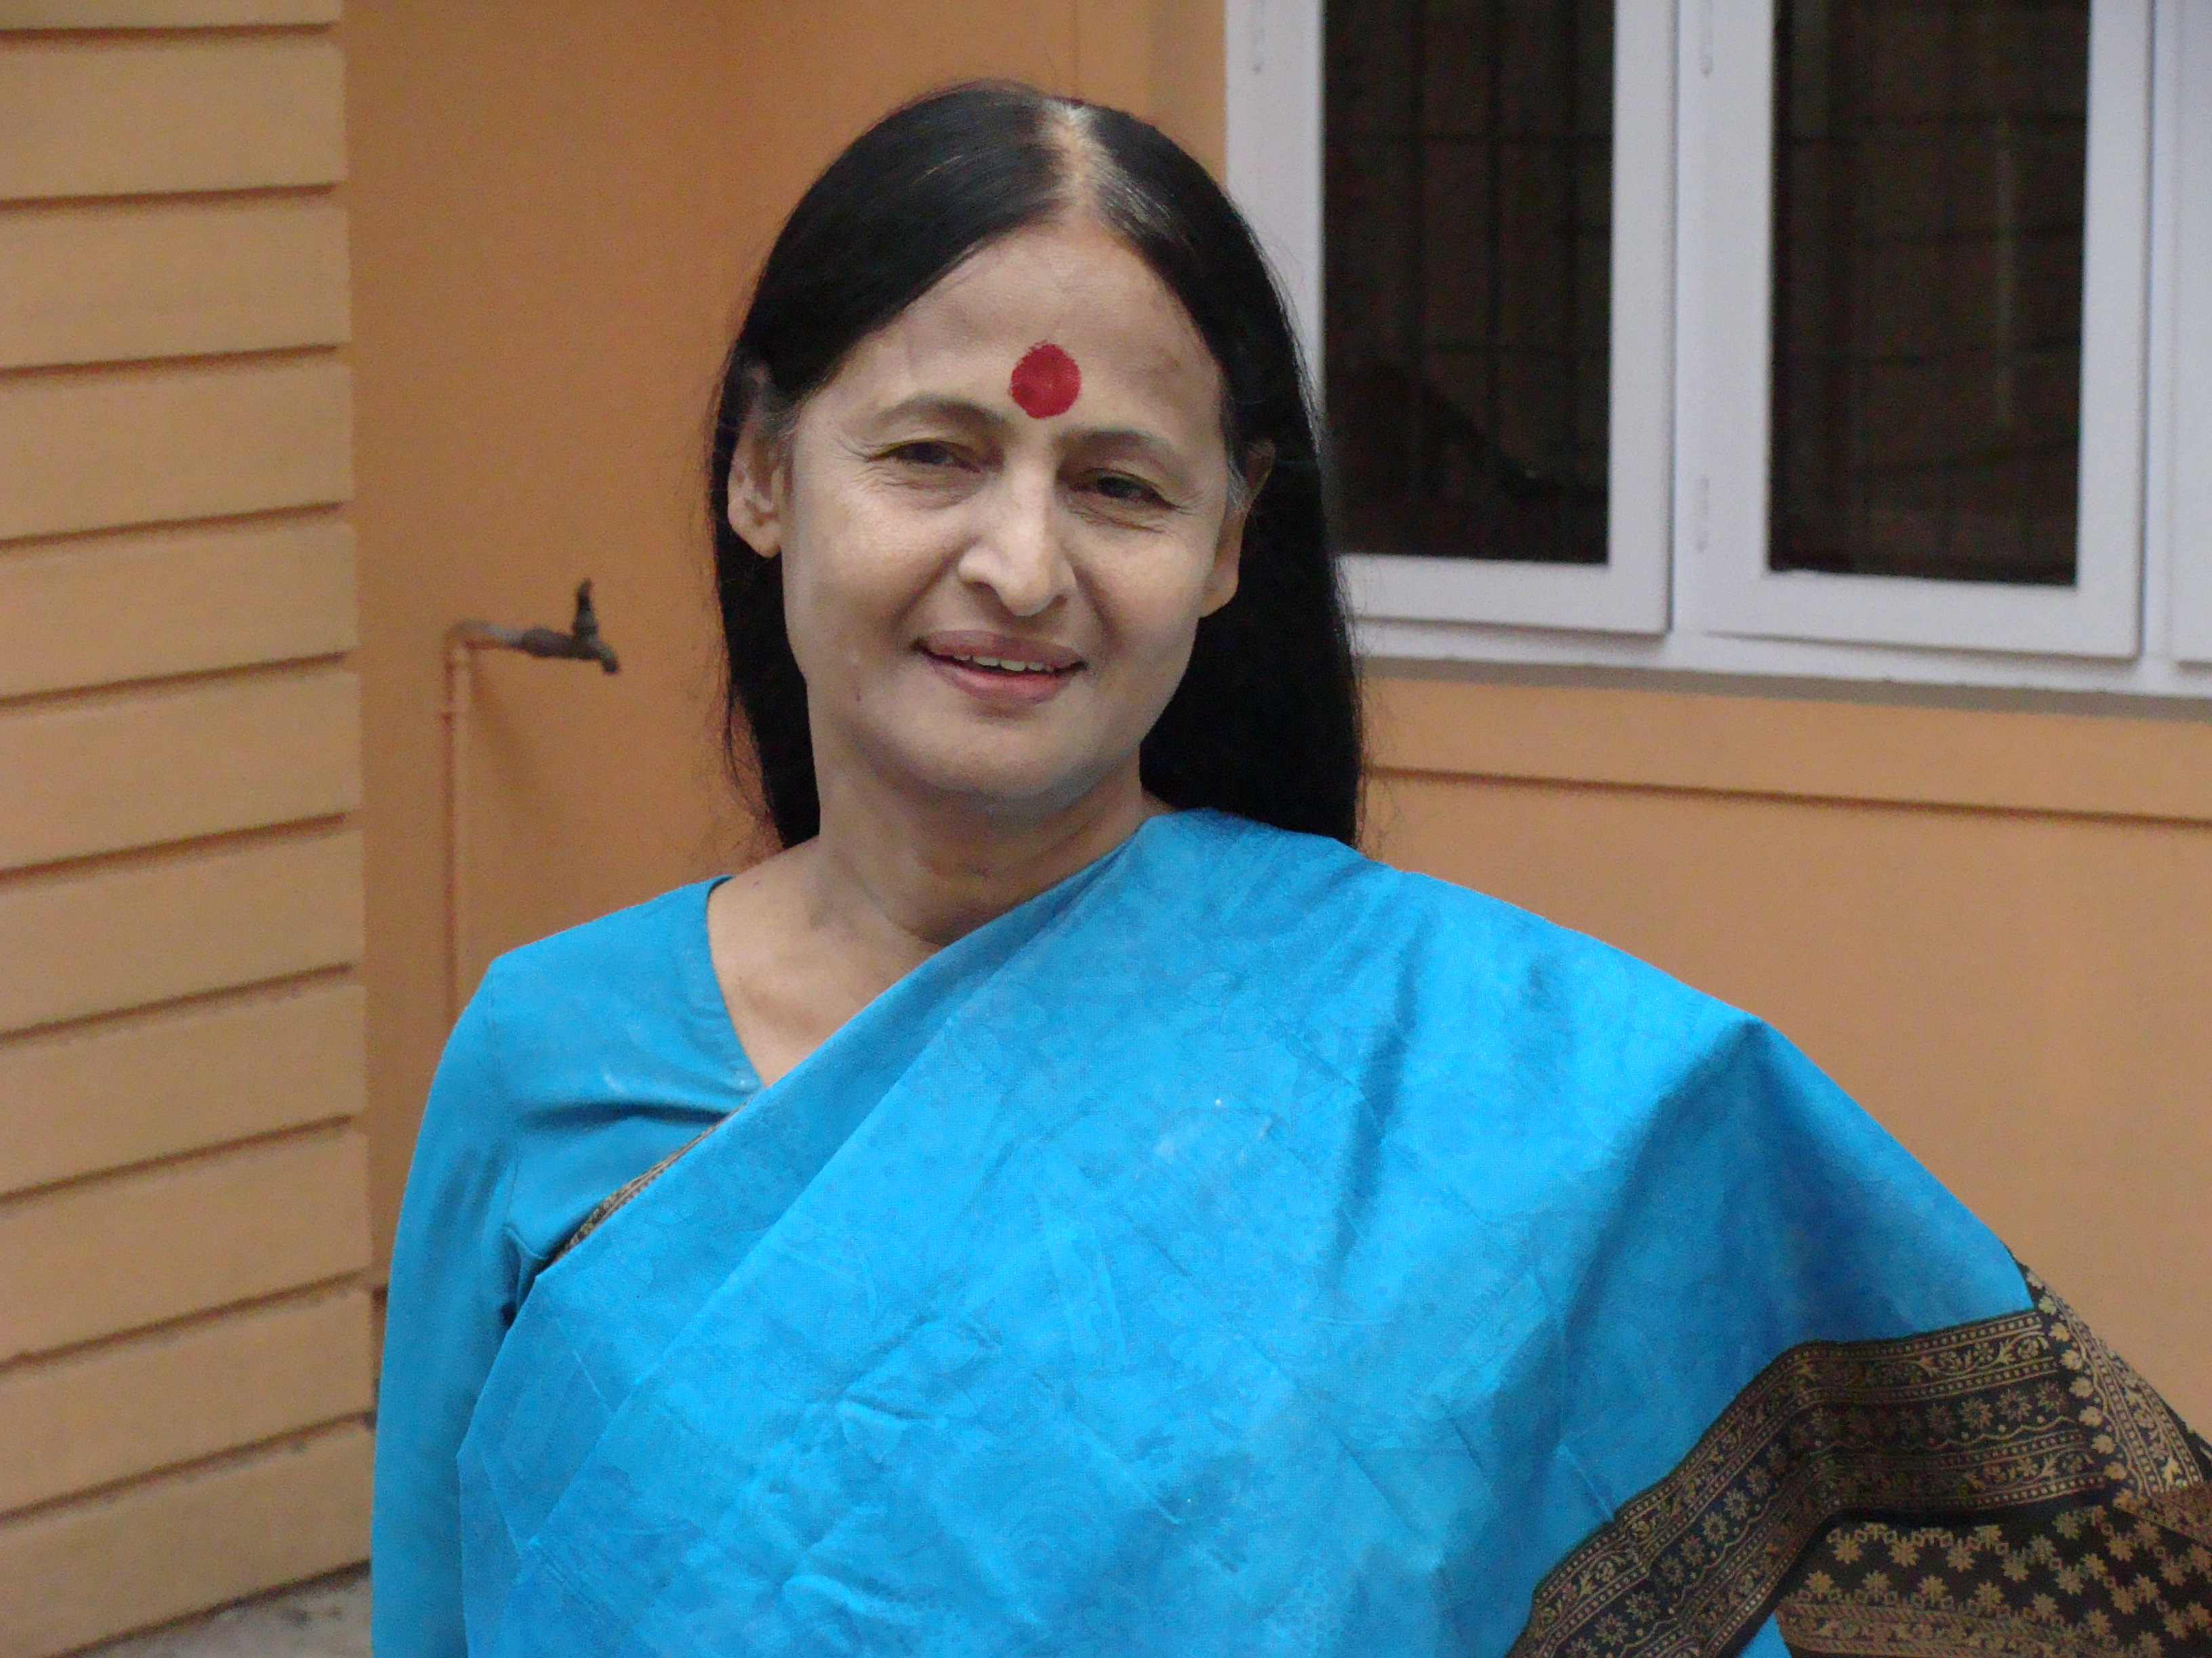

Dr.V.Thankamani
Dr. V. Thankamani is an eminent academician and scientist in Kerala in the field of Biotechnology. She was Professor and Head, Department of Biotechnology, Kerala Uiversity, and Senior Professor & Division Leader SBST, VIT, Vellore. She had been The Chairman, PG Board of Studies in Biotechnology, Kerala University.
And also The Syndicate Member, Kerala University.

She Founded and established the Department of Biotechnology, equipped with advanced analytical equipment and other facilities: built up a unique work culture and academic programs to groom well trained scholars both academic and professional skills.

She is Recipient of Rashtriya Gourav Award , Indira Gandhi Shiromani Award from India International Friendship Society in the year 2011 She has more than hundred international papers and a number of Books in Biotechnology. Currently she is looking after many Government and Non Government projects in the country.

